A SOFTWARE AS A SERVICE DESIGN FOR AN AUTOMATED SYSTEM TO CONNECT PATIENTS AND HOSPITALS BASED ON SERVICE-ORIENTED ARCHITECTURE

Manas Trivedi (181CO231), Omanshu Mahawar (181CO237)

manasdtrivedi@gmail.com, omanshumahawar1234@gmail.com

National Institute of Technology Karnataka, Surathkal, India

**Abstract.** Software as a Service (SaaS) is a model of software delivery which is finding major adoption in the software development industry. It is based on providing software services to tenants over the internet. In the domain of healthcare, software systems must be fast and lightweight, since such systems may be used in time-critical situations. This document focuses on creating a SaaS model for a service-oriented system which connects hospitals and patients, with a focus on users residing in remote areas.

**Keywords:** Software-as-a-service · Web services · Healthcare · Layered architecture

# 1 Introduction

## 1.1 Purpose

This document contains the design and architecture of the Software as a Service (SaaS) model for ‘An Automated System to Connect Patients and Hospitals’ (ASCPH). This document follows the functionalities and requirements identified in the SRS document of the project [2]. The primary audiences of this document are the software developers.

## 1.2 Definitions, acronyms, and abbreviations

**Table 1**. Definitions

|  |  |
| --- | --- |
| **Term** | **Definition** |
| Appointment | Arrangement to meet a doctor working at a hospital at a particular time |
| Hospital Executive | A person who handles the updation of hospital details and approval and rejection of appointments. |
| Patient | A person who uses ASCPH to access services such as finding a hospital and booking appointments for the treatment of diseases. |
| Service | A self-contained unit of software that performs a specific task. |

### 

### Table 2. Acronyms and abbreviations

|  |  |
| --- | --- |
| ASCPH | Automated System to Connect Patients and Hospitals |
| HEx | Hospital Executive |
| ID | Identification |
| SaaS | Software as a Service |

# 

# 2 Software as a Service

Software as a Service (SaaS) is a method of providing software to clients over a network, usually the internet, in the form of a service. In this method, the vendor of a software deploys the same on a server, which is then typically accessed by clients through a web browser. The clients do not need to buy the software or any dedicated infrastructure for using the software, but can use it through a subscription. This model ensures that the client does not need to pay heavily for unused licensing, and shall pay only for what they are using.

There are three factors which must be considered during the development of an application based on the SaaS model [1]:

1. Multi-tenancy: A single instance of the application serves multiple clients. This involves efficient sharing of resources among the clients.
2. Scalability: The system shall be able to handle an unpredictable number of users without loss in quality of service delivered.
3. Configurability: Clients shall be able to customize certain aspects of the application according to their requirements.

The SaaS model has been considered for providing access to the ASCPH application for the following reasons:

1. SaaS ensures that users can access the services of the ASCPH with an internet connection. There is no need for the user to download any software or purchase infrastructure and hardware.
2. Changes to ASCPH can be easily made to a single codebase. There is no requirement of maintenance of older versions, which is an issue with on-premise software.
3. Software resources are shared efficiently among the users of the application, such as the database and services.
4. Since the number of users of ASCPH is unpredictable, the system must be scalable, which is a feature of most SaaS systems.

# 

# 3 Design

The application is divided into three layers - the User Interface layer, the Application layer, and the Database layer.

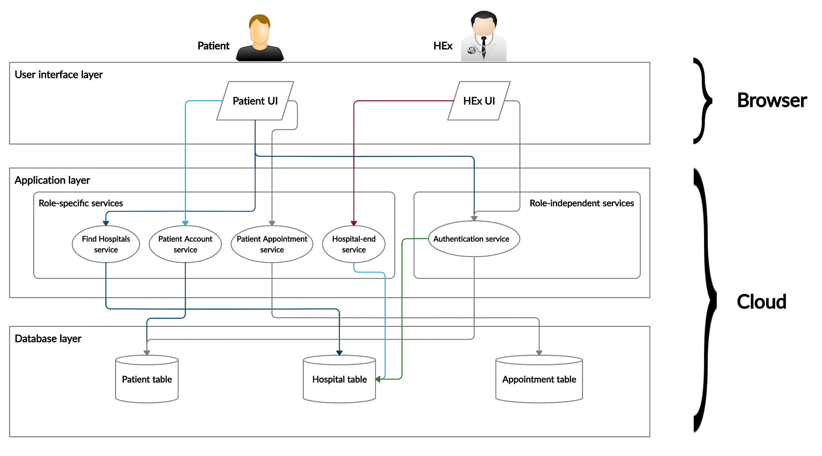

**Fig.1.** Conceptual Architecture Design

## 3**.1 User interface layer**

This layer consists of two kinds of user interfaces, based on user classes. The first user interface is the Patient user interface.. Through this interface, patients shall be able to find hospitals, create and update an account, and book, view, and cancel appointments. The second user interface is the HEx user interface. Through this interface, the HEx of each hospital shall be able to update their respective hospital’s details, and view, approve, and reject appointments.

## 3**.2 Application layer**

This layer consists of the different services that the user shall consume through the user interface. There are four role-specific services and two role-independent services.

### **Role-specific services**

There are two user roles in ASCPH - the patient and the HEx. The patient shall access three role-specific services, namely the Find Hospitals service, the Patient Account service, and the Patient Appointment service. The HEx shall access one role-specific service, namely the Hospital-end service [2].

#### Find Hospitals service

This service will be used by a patient to find and locate hospitals. The user may select requirement(s) such as treatment of Covid-19, treatment of Asthma, etc. Based on the selection made, a list of nearest hospitals will be displayed to the patient. The patient may then view the details of each hospital present in the list. These details will include the location and the types of treatment available.

#### Patient Account service

This service will be used by the patient to create an account, and later update the details of the account if required. Using this account, the patient will be permitted to book, view, and cancel appointments.

#### Patient Appointment service

Upon selecting a hospital by using the Find Hospitals service, the patient can then book an appointment with the hospital for the treatment of one or more diseases, by specifying the type of treatment required, and the date of the appointment. The patient can also view the appointments he/she has requested, along with their statuses. The status of an appointment can be either ‘requested’, ‘approved’, ‘rejected’, or ‘cancelled’. Upon viewing the list of appointments, the patient shall be allowed to cancel an appointment. Appointments can be cancelled regardless of their status.

#### Hospital-end service

This service will be used by the HEx for managing the hospital details, such as availability of treatment for specific diseases, type and number of available resources, etc., and appointments requested by patients with the hospital. The HEx shall be permitted to approve or reject appointments. If the HEx decides to approve an appointment, the HEx must also specify the time of the appointment.

It must be noted that the HEx won’t be permitted to create the hospital as an entity in the ASPCH - it would be done by the developers upon receiving a request from the hospital for the same.

### **Role-independent services**

#### Authentication service

This service will authenticate the users, which shall further decide the user interface to be displayed, the tables that can be accessed, and the records which can be viewed and modified.

#### Proxy service

This service shall act as the communication link between the role-specific services, the authentication service, and the database. It shall receive requests from the other services, which it will convey to the database, and shall return responses from the database.

## 3**.3 Database layer**

There are three tables present in the database for ASCPH, the Patient table, the Hospital table, and the Appointment table.

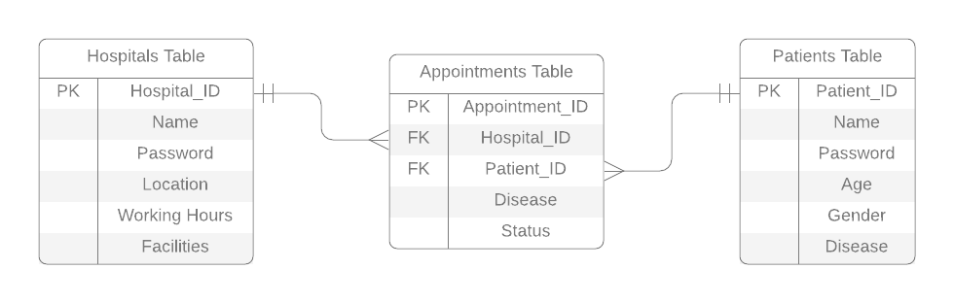

**Fig. 2**. Entity Relationship diagram

### **Patient table**

This table contains the details of patients registered with ASCPH. It is used by the Authentication service and the Patient Account service through the Proxy service. The attributes present in this table include the Patient ID, password, name, age, and gender.

### Hospital table

This table contains the details of the hospitals registered with ASCPH. It is used by the Authentication service, the Find Hospitals service, and the Hospital-end service through the Proxy service. The attributes present in this table include the Hospital ID, password, name of the hospital, location, working hours, and the facilities provided by the hospital.

### Appointment table

This table contains the details of the appointments requested by the patients with the hospitals, along with their status. It is used by the Patient Appointment service and the Hospital-end service through the Proxy service. The attributes present in this table include the Appointment ID, Patient ID, Hospital ID, disease for which treatment is desired, date and time of the appointment, and the status.

# Conclusion

A SaaS model for ASCPH has been described in this document. A three-layered architecture was selected, the first layer being the User Interface layer, present on the client side, the second and third layers being the Application layer and the Database layer respectively, present on the server side. The Application layer consists of the business services to be provided to the clients, while the Database layer consists of the data tables used by the application. The Application and the Database layers effectively constitute the software being provided as a service to the clients, by the vendor, which can be accessed by the clients through the User Interface layer.

# References

1. Sommerville, I.: Software Engineering, 10th ed., pp. 490-519. Pearson India (2017)
2. Trivedi, M., Mahawar, O.: Software Requirements Specification for An Automated System to Connect Patients and Hospitals Based on Service-Oriented Architecture (2020)